Z

/

Kirin Harrington

18harringtonk@utcsheffield.org.uk

Plan and prepare for an interactive media project

Unit 2

Contents

Ideas Development 1

Virtual reality 2

Augmented reality 2

Interactive PowerPoint 2

Website 3

360 tours 3

Chosen Audience/End-user 5

Virtual reality 5

Augmented reality 5

Interactive PowerPoint 5

Website 5

360 tours 5

Chosen Audience/end-user conclusion 5

Technical Aspects 6

Fonts 8

Design aspects/outline 10

12

# Introduction

We have been asked to make an interactive media element for an industrial museum called Kelham Island Museum, the product needs to reflect the theme and portray some of the exhibits that are currently in the museum, it currently has very few interactive elements, so they have tasked us with creating products to enhance the experience.

# Ideas Development

## Virtual reality

Could include a reverse-engineer style of display where you take apart a working model to see its inner workings. It could also include a back-in-time scene where you walk around and can view an area as it used to be, with added information that pops up depending on where you are. Would require 3d models with images for textures, and audio files for a more immersive experience, but videos wouldn’t work well as that could trigger motion sickness or make some people feel disorientated.

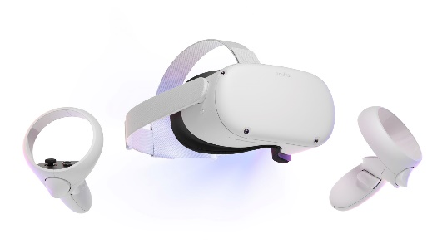

## Augmented reality

Could be a phone app which, when you point it at exhibits you can see the exhibit through the camera, and it is enhanced by information pop ups or animation of the exhibit which could be achieved by GPS or scanning the exhibit. Has little cost for the museum as it is an app which requires no physical maintenance or equipment that needs to be purchased. Could use videos or animations with audio, images could work but would be less engaging than videos,

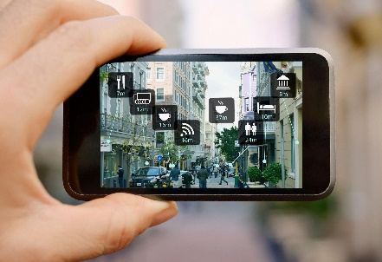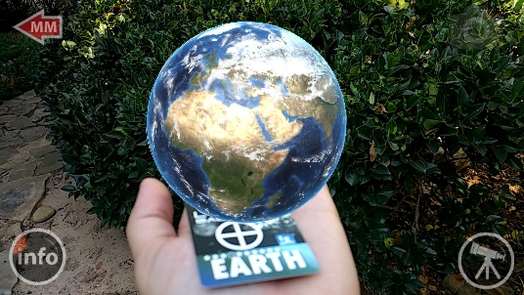

## Interactive PowerPoint

Can be shown on a tv screen next to an exhibit, the user could swipe or tap to move on to a new screen which would give extra information on an exhibit and could include videos, it could also be made contactless with the use of sensors to remove any problems with breakages and any covid dangers. All media types, images, video and audio, would work well for this idea, images could be used in addition to text to provide information, and videos could show the object that the display is referring to in action to give the user an idea of how it would work/behave.

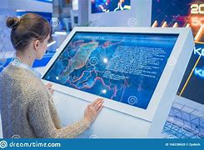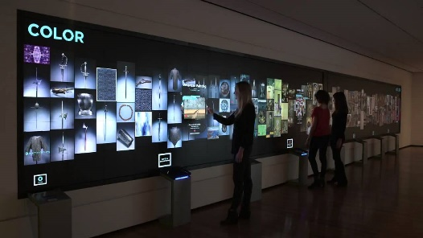

## Website

A website giving information about exhibits or the museum as a whole which could serve as a way to get users to come to the museum or to add the experience while you were already at the museum. Images could showcase some of the museums exhibits to either encourage the visitors to come to the museum or just as an online replacement which could be accompanied by text explaining the exhibit or a video of someone talking and explaining the exhibit which would be enhanced with the addition of audio.

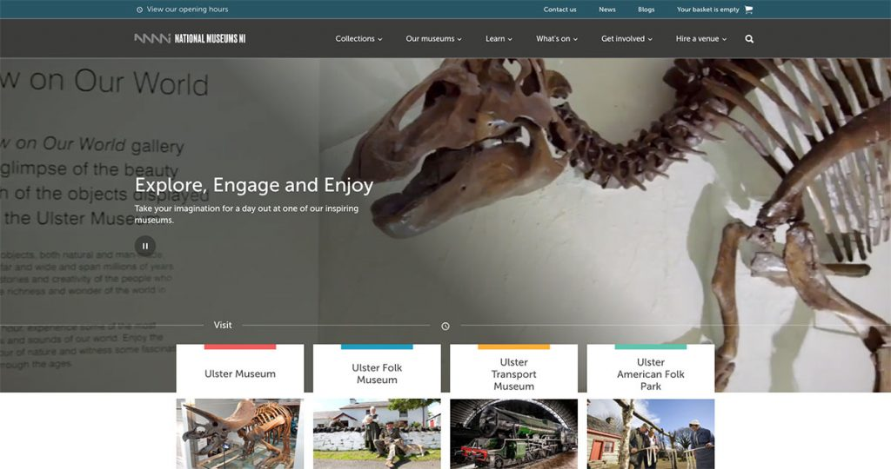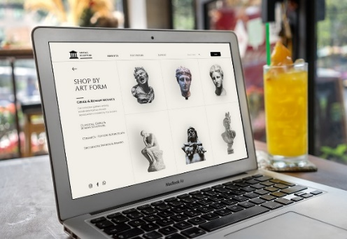

## 360 tours

A 360 tour is a great way to do a virtual tour of a museum. It could be shown on the museums website to give the user an idea of what the museum has to offer and can encourage them to visit. It could also be a good way to get a user engaged in what the museum has to offer through covid when people may not be able to visit. Images and maybe audio would work for this project, 360 images to give user the ability to look around the room and audio to either give some background noise or a voiceover explaining what is in the room/what the rooms purpose is, a video could be confusing for some users but seeing the room in action could also be a valuable experience.

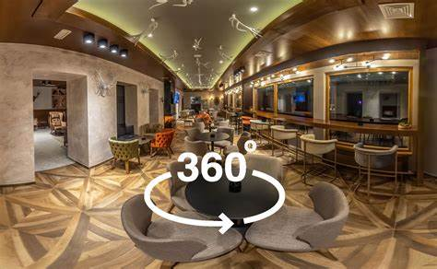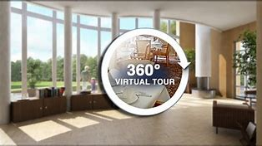

# Chosen Audience/End-user

## Virtual reality

13+ Is very engaging and quite fun to use. However, it’s use is limited to people over the age of 13 because the headset will not fit on most young children. Some adults are wary and don’t feel comfortable with the technology as well, the chance of this seems to increase with the age of the adult, so the older the adult the higher the chance that they will refuse to use it.

## Augmented reality

3+ Useable by everyone as it is as simple as a phone app which needs little interaction apart from pointing at an exhibit, animations are interesting, especially to young audiences which could get them engaged and older audiences will enjoy the extra information.

## Interactive PowerPoint

5+ Useable by most with the exception of people who are too short to use the touch screen, this is easily fixed with a step or just a lower screen however, it would add an interactive element and can make a display more interesting for everyone rather than just blocks of text which some people may just ignore.

## Website

18+ Targeted more towards adults as it has less interactive content and is therefore less engaging for younger audiences.

## 360 tours

10+ Requires some level of technology understanding to be able to navigate the tour, therefor it is less suited for young children and more for children and adults who have some experience of technology.

## Chosen Audience/end-user conclusion

For teens and young adults VR would be by far the most appealing, but would also enjoy augmented reality, for children would probably prefer an interactive PowerPoint with older generations choosing to use either Website or interactive PowerPoint .

# Technical Aspects

|  |  |
| --- | --- |
| MP4 | Is a format for storing audio and video, it can also store images and subtitles. It is widely supported across devices and good for streaming over the internet. It allows for a lot of compression, which, although it will decrease the quality, it will also greatly decrease the file size, however, it uses lossy compression which means that any data which is removed for compression is permanently lost. |
| AVI | It has extremely high quality and doesn’t require any specific hardware or software to run, increasing the amount of people who can use it easily. However, it lacks the ability for user interaction, such as pause and play features and if they are uncompressed, they have huge file sizes. |
| Gif | Allows for transparency, gives the option to transfer image files to animations or images and uses lossless compression for higher quality images. However, it has a restricted number of colours and doesn’t support shadows. |
| Jpeg/Jpg | The best file type choice for image compression, but compromises on image quality when compressed, when not compressed it is very high quality and often used in the photography industry. Unfortunately, it doesn’t support transparency making it difficult to change the image background. 666kb |
| Png | Ideal for digital art and uses a lossless compression type to make sure the image is high quality, however, they are usually one of the largest image file type and not great for photography.  7,147kb |
| Bmp | Very good image quality but doesn’t support effective image compression and can therefore be very large especially if they contain a large number of colours  24,301kb |
| Mp3 | Supports compression and therefor can have a small file size, this means that portable storage devices can hold many files. However, it only uses lossy compression meaning that converting to a different file format will result in degrading audio quality. |
| WAV | An uncompressed format which means there is no loss in audio quality therefor the audio is relatively easy to edit, and it allows us to listen to very high audio quality. However, wav files are incredibly large and can reach sizes of 500MB and therefor impractical for portable devices due to their size. |
| MOV | Can hold different media elements such as audio and video in one place, however, MOV files work exclusively on the QuickTime media platform so if your device doesn’t support that platform you have to convert the file to a different format |

## Fonts

Kelham Island Museum – agency FB

This font is compact and regular so space can be saved, and it is also simple and easy to read. It gives off a technological feel so could be used for a tech centred product.

Kelham Island Museum - Edwardian Script

This is a “fancy” display font which means that it could be very difficult to read, especially for children or people with sight impairments, it has quite an old-fashioned style so would work in any product that fits that style.

Kelham Island Museum – Comic Sans MS

This font is quite spaced out, simple and therefor extremely easy to read, very good for young children and therefor would fit well in any child related product.

Kelham Island Museum - Chiller

This is a display font so could be hard to read, the varied thickness of the letters doesn’t help meaning it can be very hard to understand, especially for young children or people with sight impairments. This font would fit very well in a horror focused capacity.

Kelham Island Museum – Forte

Titles

This is a fancy display font which has quite a relaxed and has an almost playful feel it can be very difficult to read because of the style and how the letters are placed.

# Design aspects/outline

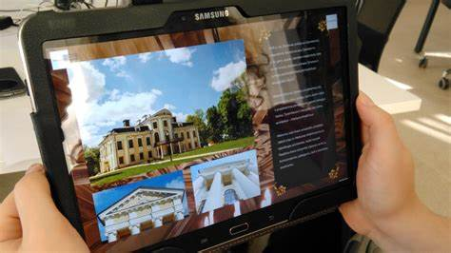

This app utilises the rule of thirds by placing the image in the left two thirds and text on the right. The background includes brown earth-y colours to convey a theme of nature, this is continued by showing the museum with the trees and land around it. They also have an empty border around the actual usable part of the app to allow for devices with different screen resolutions to also use the app without it cutting off any content.

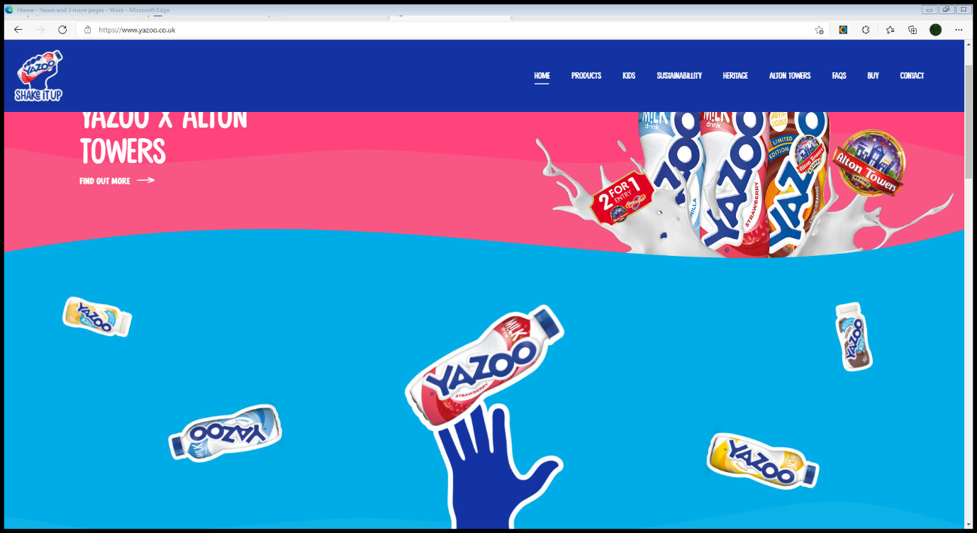This website uses contrasting colours of pink and blue for a more vivid and brighter feel, these colours stereotypically were used to appeal to specific genders so using both could be a way to try and appeal to both, it uses very “fun” colours to target children which is emphasized by the font giving it an overall “playful” feel which fits the product well.

# Alton Towers Resort: UK Short Breaks, Theme Park & Waterpark and 1 more page - Work - Microsoft​ Edge

The colour blue represents strength and reliability which could help the user trust this website, the red elements provoke excitement and a sense of urgency while raising the audiences heart rate which could encourage impulse buying in some people. They use a nice easy to read font and a white and blue colour combination for the text meaning it stands out and is accessible for everyone.

# Final conclusion

For Kelham island we would make sure to use a colour scheme which reflects their industrial history, videos which show a representation of how parts of the museum used to be with accompanying audio. A simple, easy to read large font which gives an industrial feel would be ideal. High quality but efficient file types would give the best look, such as PNG for images because it is high quality and not too large, (BMP is simply too large to be useable,) MP4 for images because of how widely it is used meaning that nearly all platforms support it, allows decent quality and is quite a small file type. Mp3 for audio because again, it is widely used and supported and allows compression while still retaining a good audio quality. For Kelham Island we would probably want to use virtual reality, because it can immerse the user and almost take them back in time, an interactive PowerPoint do add an interactive feel to where there may not have been one before. Or a 360 tour to allow for remote access so the user can get an idea of the museum without having to visit, which could encourage them to visit.